**Exercise_No:10**

**Date:23-11-2020**

**Aim:**

**To print the output for the given problem using python.**

**Program:**

**def string_test(s):**

**d={"UPPER_CASE":0,"LOWER_CASE":0}**

**for c in s:**

**if c.isupper():**

**d["UPPER_CASE"]+=1**

**elif c.islower():**

**d["LOWER_CASE"]+=1**

**else:**

**pass**

**print("No of upper case characters :",d["UPPER_CASE"])**

**print ("No of lower case characters:”, d["LOWER_CASE"])**

**s=input ()**

**string_test(s)**

**Link:**

[**http://103.53.53.18/mod/vpl/forms/submissionview.php?id=325&userid=1684#**](http://103.53.53.18/mod/vpl/forms/submissionview.php?id=325&userid=1684)

**output:**

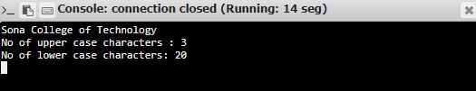

**Result:**

**Thus, the output for the program is successfully**

**Executed.**